Assignment #8 - MongoDB Part 4

Completion requirements

Opened: Monday, 28 November 2022, 12:00 AM

Due: Friday, 16 December 2022, 12:00 AM

Implement (and test) the following endpoints:

\* Add multiple elements at once (HINT: use insertMany method)

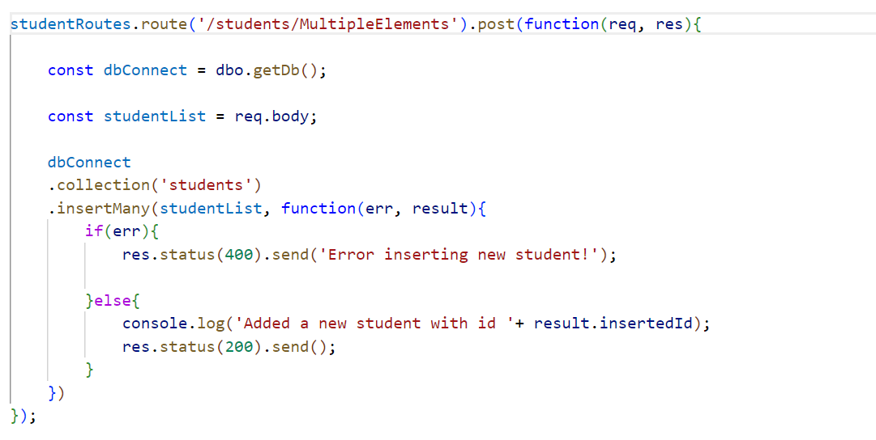

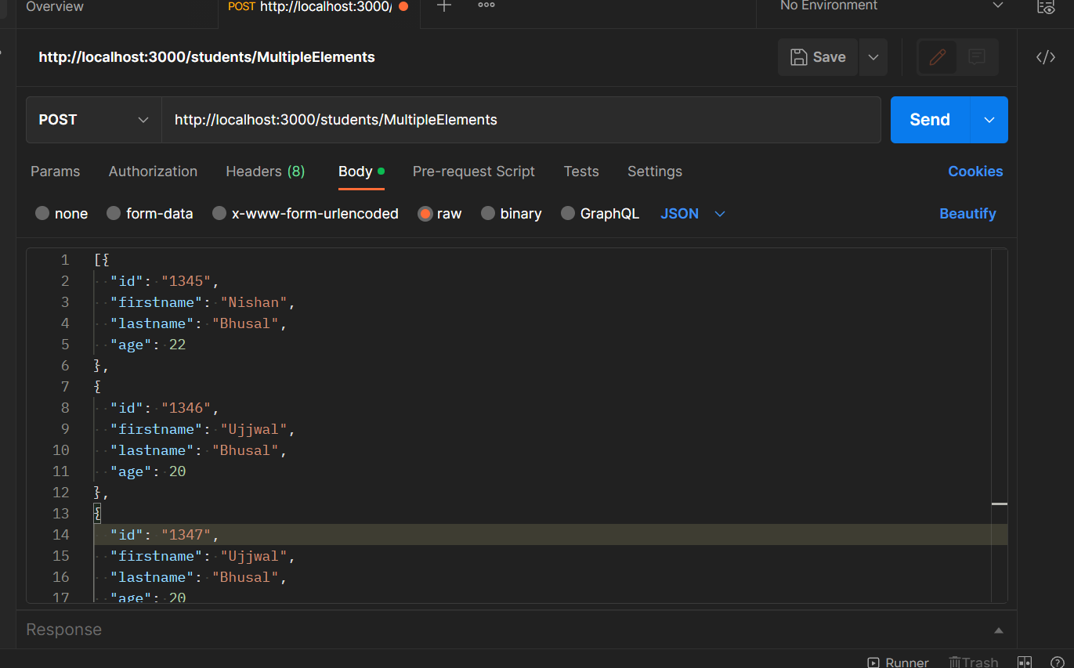

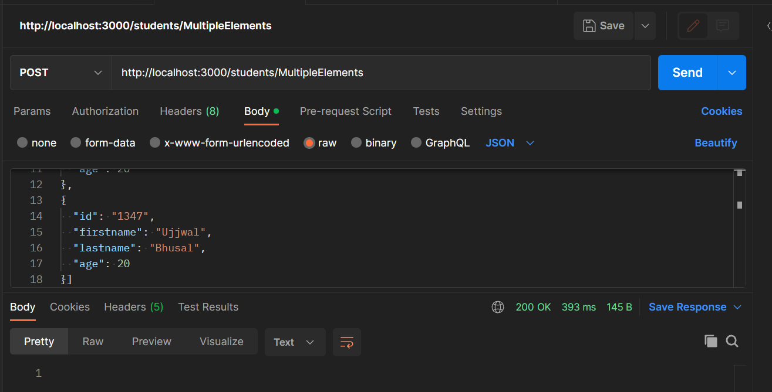

\* Filter students by last name (pass a last name parameter by url)

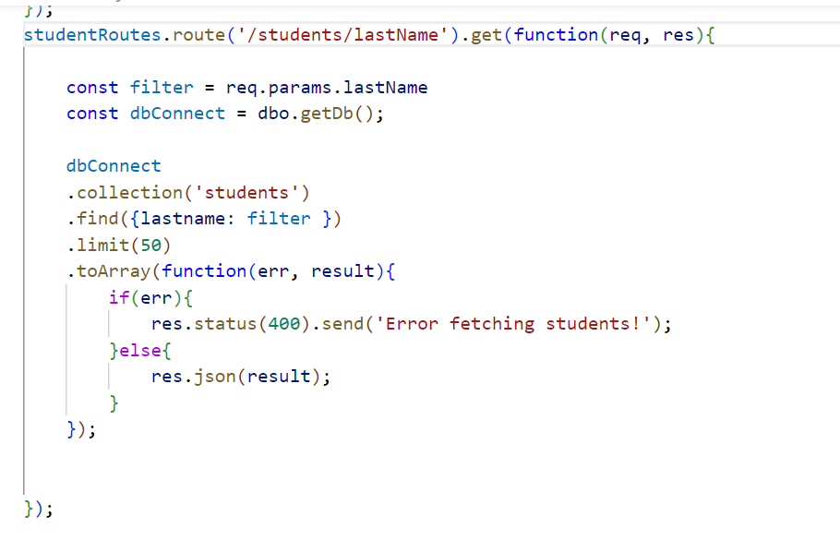

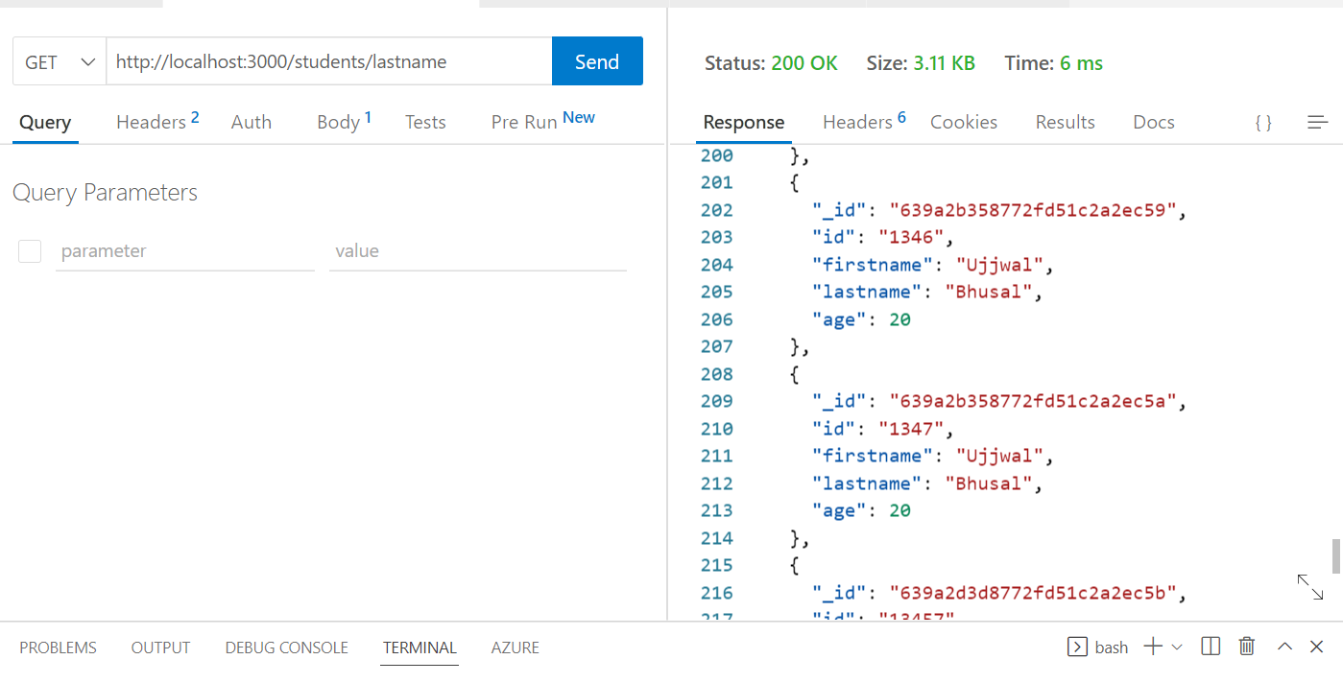

\* Return all students younger than a certain age (the value is passed by query or body).

